**LAB REPORT – 3**

**Title:** Measure the input and output response of the operational amplifier and analyzing the relationship between frequency and relative phase.

**Purpose:**

* The purpose of this lab is to understand the operational amplifier and its functions
* Analyze the measurements taken from the oscilloscope and plot the graph between the frequency and relative phase

**Requirements:**

* Prototype board
* Resistors
* Capacitors
* Operational amplifier
* Breadboard
* Connecting wires
* Digital Multimeter
* Oscilloscope

**Description:**

**Resistor:** Resistors are the device which are used to control the direction of current flowing to a circuit by applying resistance**.**

**Digital Multimeter:** It’s an electrical tool which is used to measure the current (amp), Voltage (Volt), Resistance (Ohms Ω)

**Breadboard:** It’s a board which helps in building the electrical circuits.

**Capacitor:** It is a circuit component which is designed to store the electrical charge.

**Oscilloscope:** It’s an instrument which measures frequency, voltage,phase and shows the wave shape.

**Operational amplifier:** An operational amplifier (often op-amp or op-amp) is a DC-coupled high-gain electronic voltage amplifier with a differential input and, usually, a single-ended output.

**Circuit 1**

**Inverting operational amplifier**

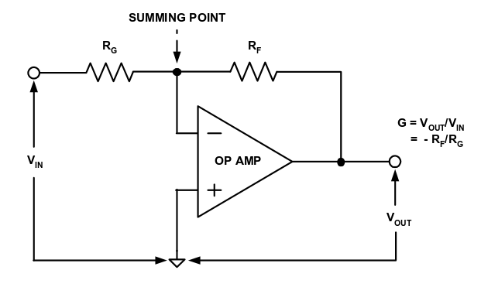

Neither of these diagrams shows the power supply for the op-amp. Use the +15V and -15V terminals on the power supply, but adjust the outputs down to +12V and -12V.

Build an inverting amplifier with a gain of 10. (Use moderately large resistors.) Then test it by using the frequency generator from the power supply board. Display both the input and output traces on the oscilloscope for a sine wave of 1KHz; if necessary adjust the amplitude of the frequency generator so that the amplified signal is not clipped off at the top and bottom.. (Since the maximum voltage the op-amp can produce is the power supply voltage, in this case 12V, if the input signal is greater than 1.2V, there will be a flat spot on the top of the amplified signal.)

Note the relative phase of the waveforms.

**Observation:**

In the above circuit the input labelled "-" is referred to as the inverting input.  The operational amplifier amplifies the difference between the non-inverting input and the inverting input.  In other words, the output of the operational amplifier is:

* Op-amp output voltage = A (V**+** - V**-**) where
* A is the gain
* V**+** is the voltage at the non-inverting input (measured to ground).
* V**-** is the voltage at the inverting input (measured to ground).

Two important points to be remembered about inverting op-amp:

* No current flows into the input terminals
* The differential input voltage is zero as V+ = V- = 0

|  |  |  |  |
| --- | --- | --- | --- |
| **Frequency(KHz)** | **Input Voltage(Volts)** | **Output Voltage(Volts)** | **Phase(Degree)** |
| 1KHz | 1.24 | 12.4 | 176 |

From the above observation table we can infer that the output voltage is 10 times the input voltage. Because, the gain is 10.

We choose different resistors i.e. RF = 1KΩ and RG = 10KΩ

G = Vout/ Vin  = -RF/RG

Gain= -10

Below is the schematic circuit of the inverting operational amplifier

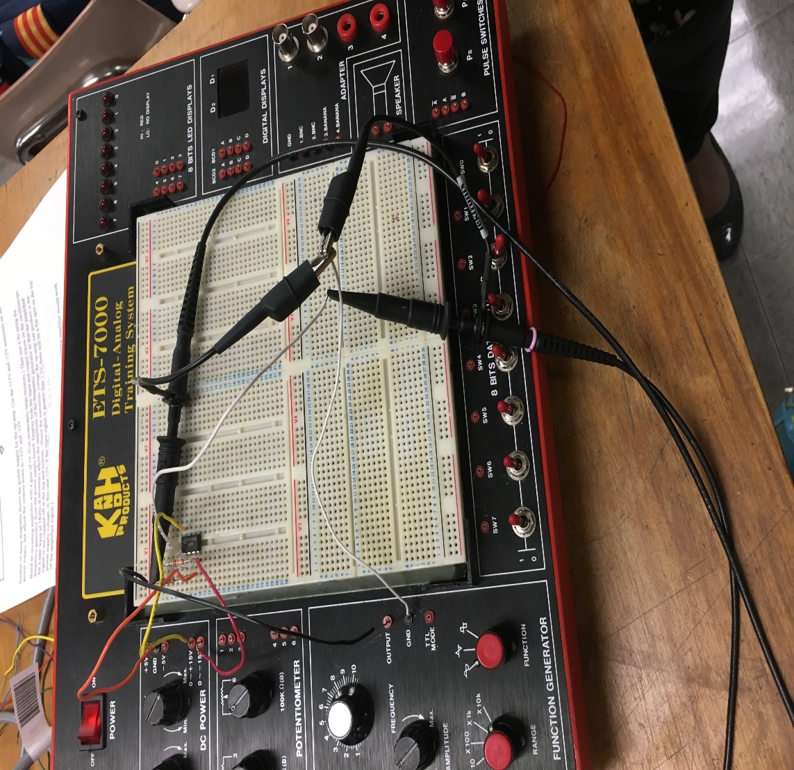

Below is the amplified waveform output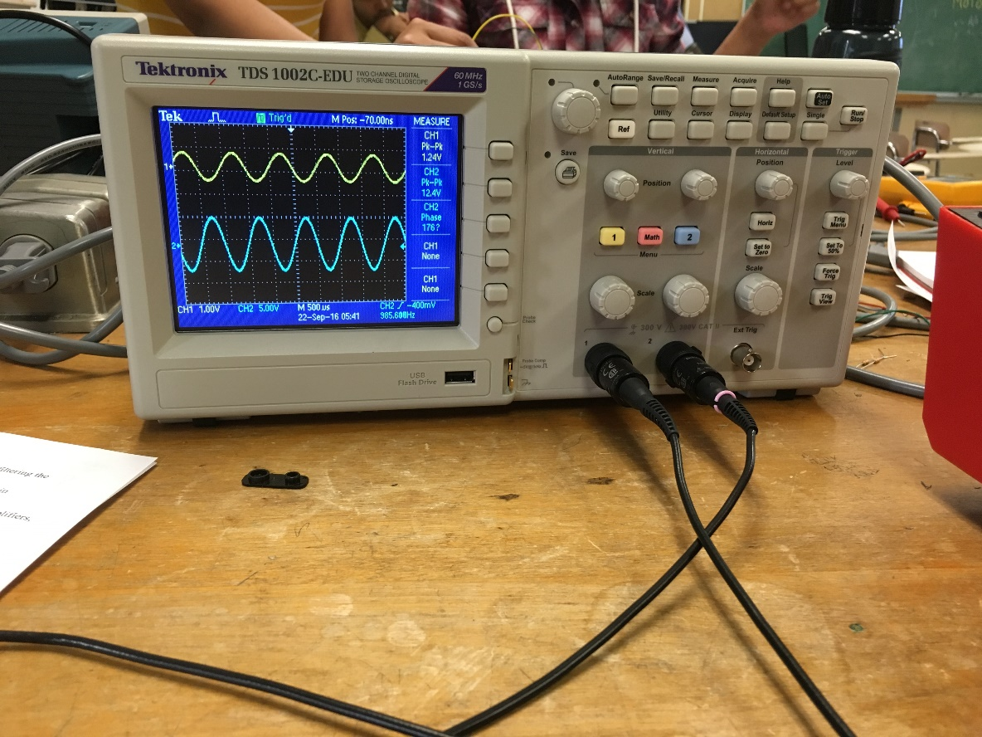

**Circuit 2**

**Non- inverting operational amplifier**

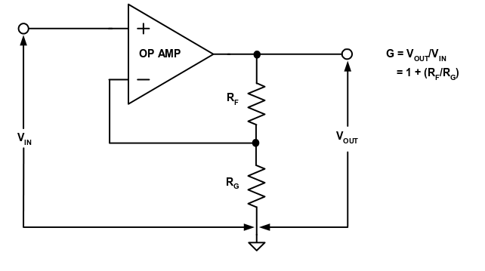

Build a non-inverting amplifier with a gain of 11 (same resistors as for the inverting amplifier should work. Make observations similar to those for the inverting amplifier.

**Observation:**

In the above circuit the input labelled "+" is referred to as the non-inverting input.

We selected RF = 10KΩ and RG = 1KΩ

Gain (G) = Vout/Vin = 1 + (RF/RG)

G = 11

Below is the table showing the values of input and output voltage measured through oscilloscope

|  |  |  |  |
| --- | --- | --- | --- |
| **Frequency(KHz)** | **Input Voltage(Volts)** | **Output Voltage(Volts)** | **Phase (Degree)** |
| 1KHz | 1.32 | 13.6 | -5.64 |

From the measured values of the input and output voltages we can infer that gain is 11 because the output voltage is 11 times the input voltage.

**Below is the schematic circuit diagram**

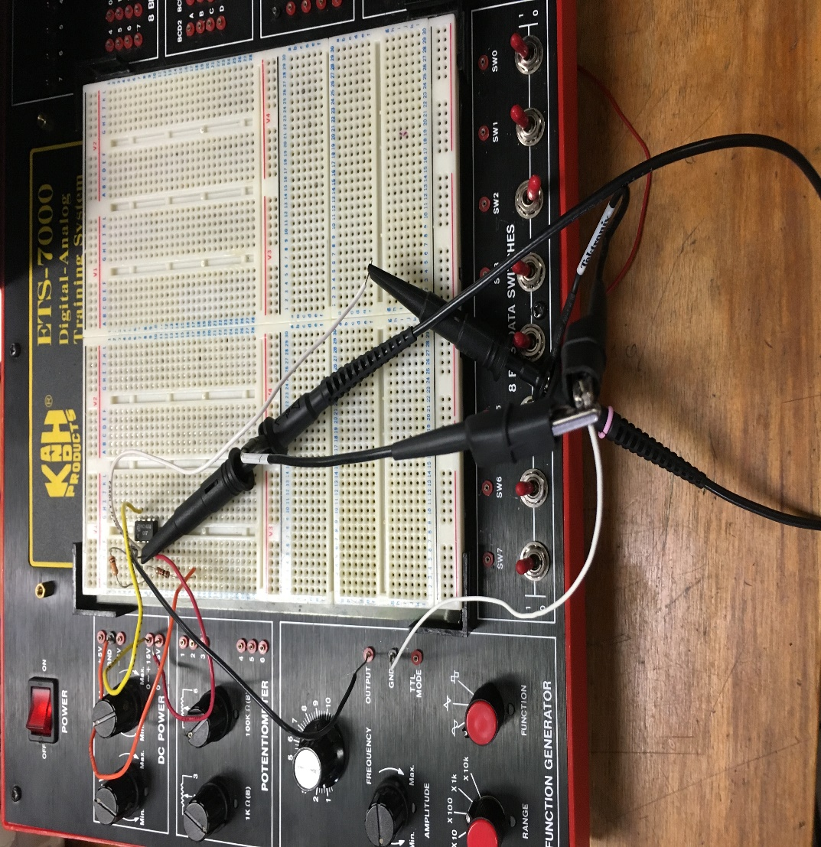

**Below is the waveform shown in oscilloscope**

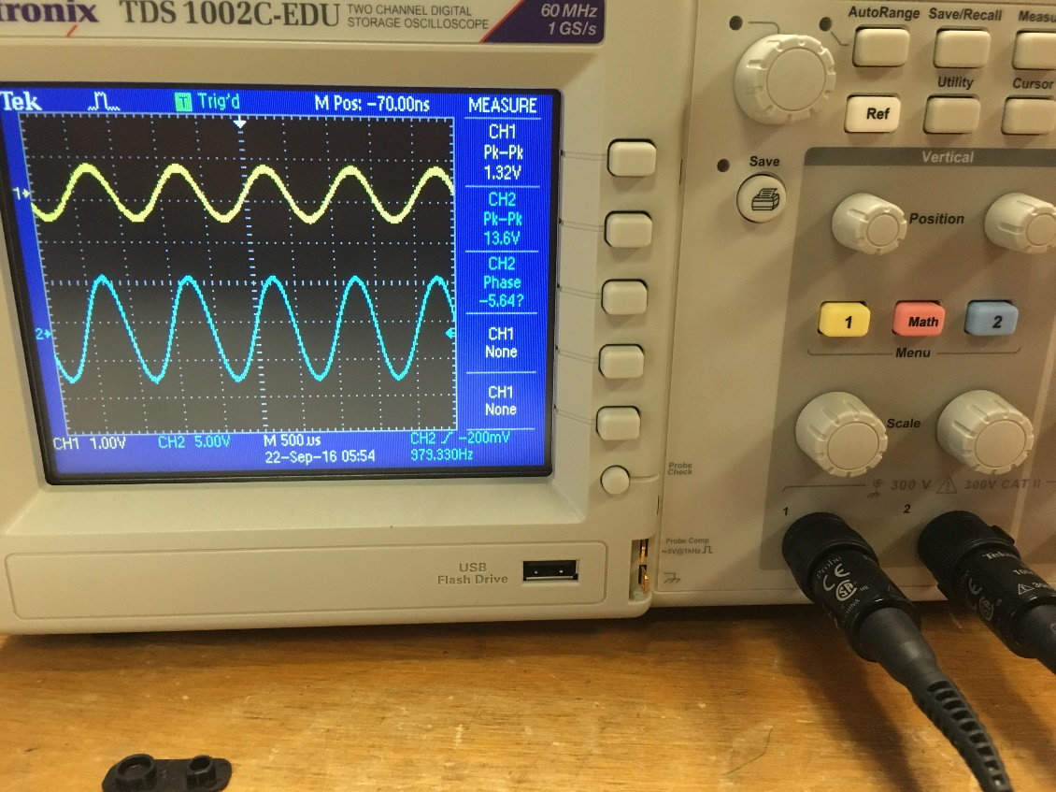

**Circuit 3**

**Sallen Key low-pass filter**

A common *Second order low-pass filter design*is this one:

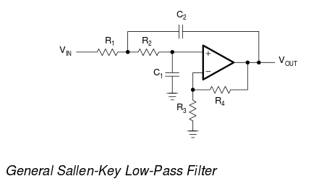

As you can see, the design includes a low-pass filter and a non-inverting amplifier, as well as a more confusing positive feedback. As you might expect, computing the values of the components for R1, R2, C1, C2 is a job for a specialized program.

One such program suggests R1 = 3.8K, R2 = 3.9K, C1= 22nF, C2 = 150nF for a corner frequency of 1K. (R3 and R4 affect the gain, but not the filtering.)

So build the filter with the indicated component values, and try it on frequencies of 10Hz, 100Hz, 1000Hz, 10000Hz, and graph the result. (If you use more frequencies you may get a smoother graph, but we're already breaking the *fundamental law of bad science: If you have have enough kinds of graph paper, you can place any three points in a straight line. Therefore, never collect more than three data points.*)

**Observation:**

**Observation table of the measured values from oscilloscope**

|  |  |  |  |  |  |
| --- | --- | --- | --- | --- | --- |
| **Frequency(Hz)** | **Input Voltage(Volts)** | **Output Voltage(Volts)** | **Input Frequency(Hz)** | **Output Frequency(Hz)** | **Phase(Degree)** |
| 10 | 7.28 | 21.4 | 10.52 | 361.9 | -4.28 |
| 100 | 7.68 | 21.4 | 106.4 | 439.7 | 113 |
| 1000 | 2.88 | 21.4 | 1101 | 357.4 | -37.4 |
| 10000 | 5.28 | 21.4 | 10420 | 367.5 | -44.2 |

Different resistors used in building the circuit:

R1 = 1.8KΩ, 2KΩ

R2 = 2KΩ , 1.8KΩ , 100Ω

R3 = 2KΩ

R4 = 1KΩ

Various Capacitors used in building the circuit:

C1 = 22nF

C2 = 23nF, 23nF, 107nF, 7nF

Below is the circuit diagram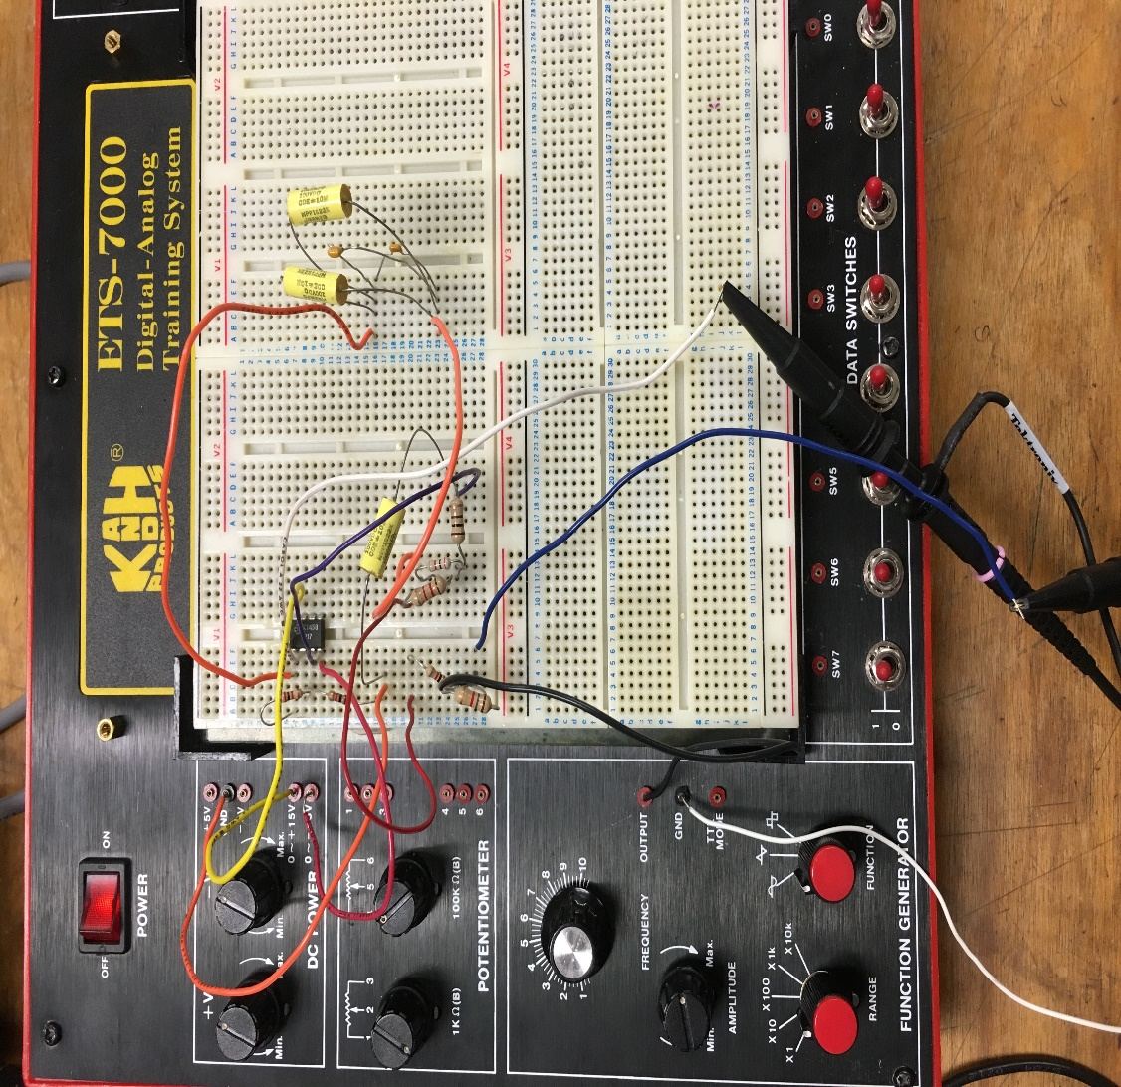

The sine waveform with 10Hz frequency measured in oscilloscope

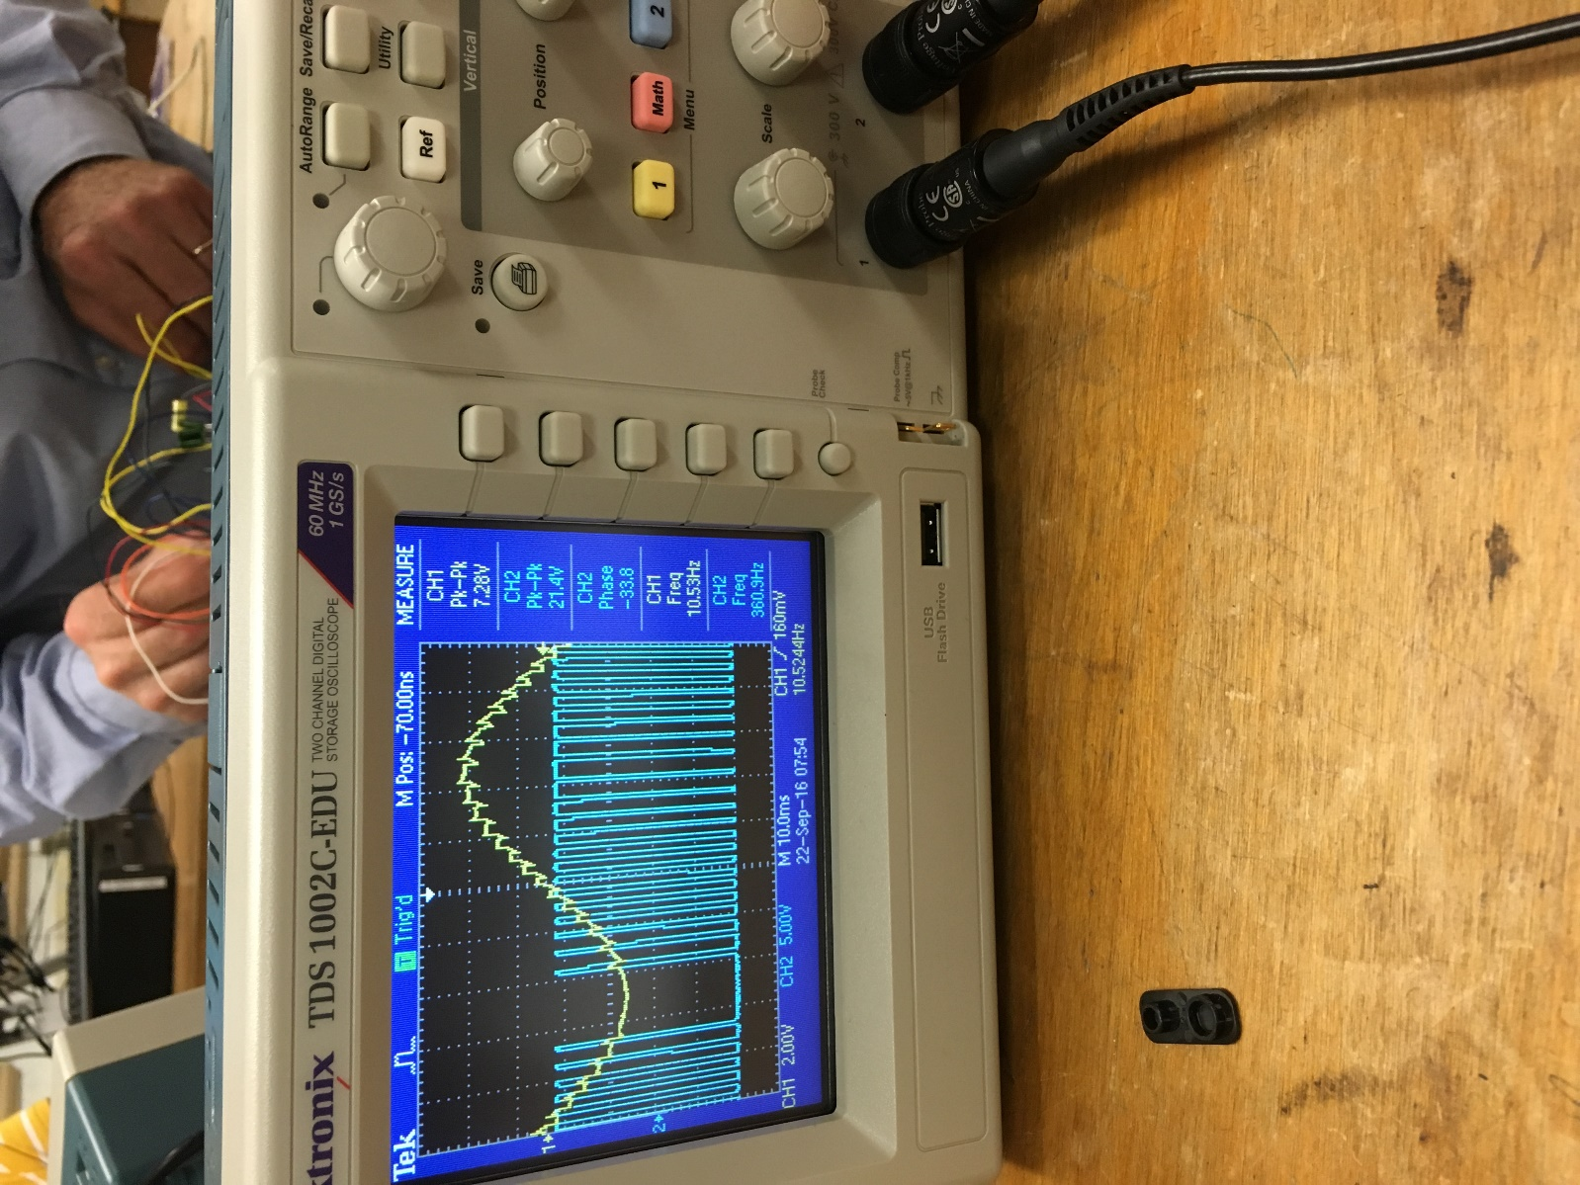

Waveform with 1000Hz frequency

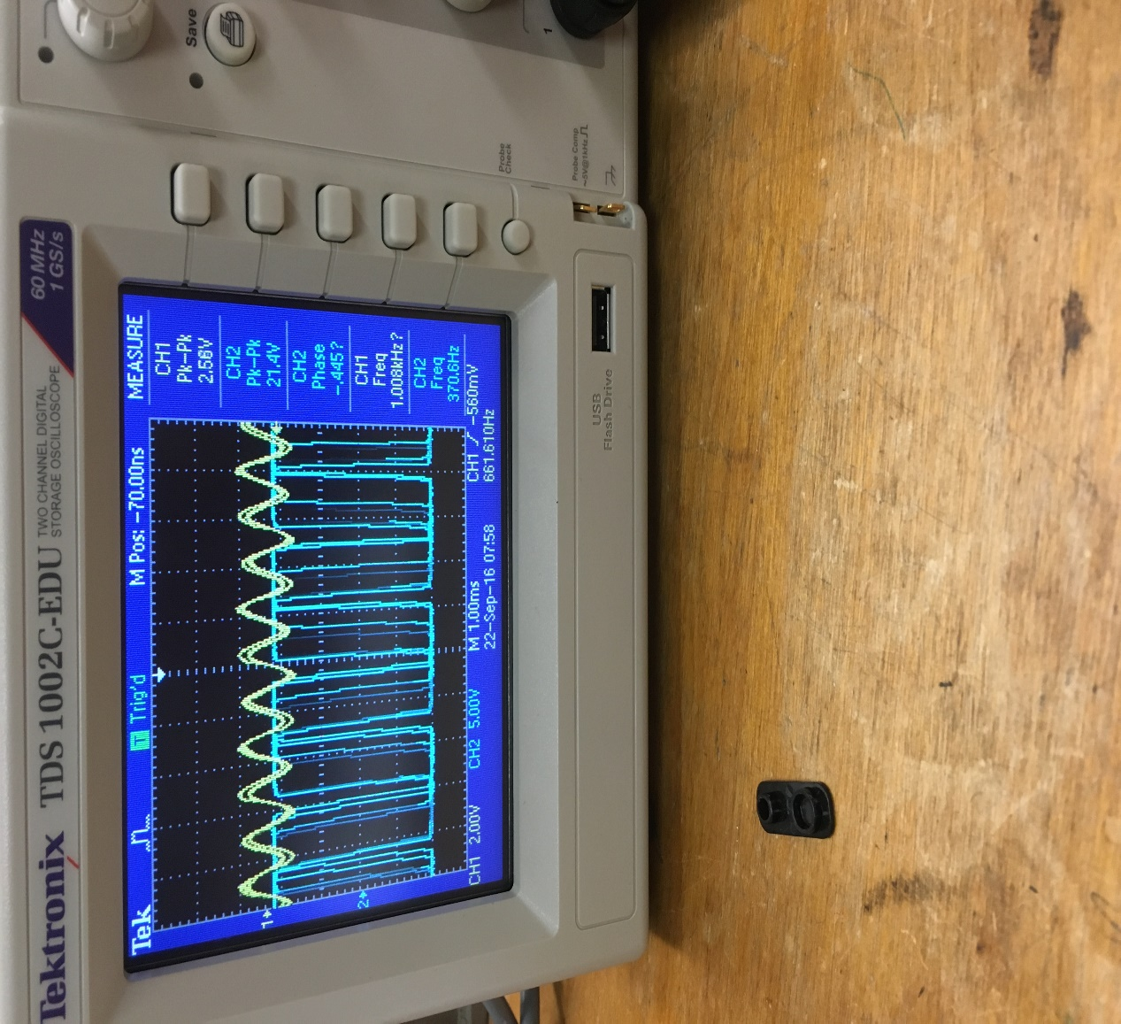

Waveform with 10000Hz frequency

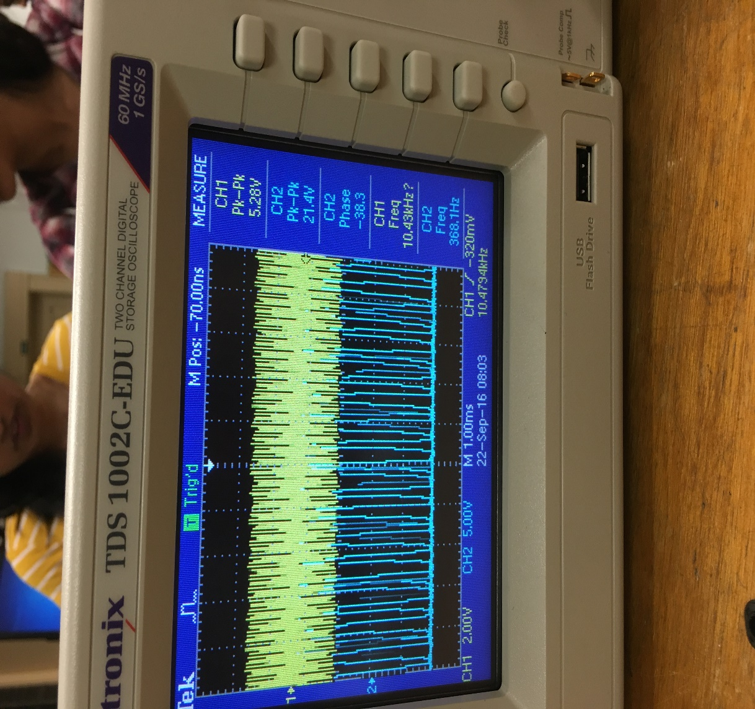

Below is the graph showing the relationship between frequency and phase

Below is the graph showing the relationship between frequency and Gain

**Arnika Vishwakarma(@01367603)**

**Lab partners- Pravalika, Lina**